**HANDLING SURVEY TICKETS**

# horizontal lineOBJECTIVE

To provide a clear, step-by-step guide for customer service agents to effectively handle survey rating tickets in a timely and professional manner, ensuring appropriate responses and actions are taken based on the customer's feedback, while also maintaining consistency in communication and ticket management across multiple platforms.

# horizontal lineSCOPE

This SOP is applicable to:

* Survey Tickets are sent from [Survey@resumebuilder.com](mailto:Survey@resumebuilder.com)
* Responses routed to [communications@resumebuilder.com](mailto:communications@resumebuilder.com)

This SOP covers the following context:

* Survey Tickets with a rate of Five (5) and/or no negative feedback
* Survey Tickets with a rate of Four (4) and/or with negative feedback

# horizontal lineROLES AND RESPONSIBILITIES

| **ROLE** | **RESPONSIBILITIES** |
| --- | --- |
| Customer Service (CS) Agents | * Responding directly to customers * Ensuring proper tagging in Zendesk is necessary for effective ticket management. * Reporting inquiries via Google Forms for documentation purposes. |

# horizontal linePROCEDURE

#### STEP 1: Determine the User's Rating

* Check the rating provided by the user/customer.
  + Rating is Five (5)
  + Rating is Four (4) & below

#### STEP 2: Categorize the feedback, if any.

* Did the user share any details about their experience?
* If yes, what type of feedback did they leave?
  + No Negative Feedback
  + With Negative Feedback / Customer Complaint
* Proceed to the next step.

#### STEP 3: Follow the Context Procedures

* Follow the steps based on the scenarios presented below.
* Reminder: Make sure that we **DO NOT** send the [**Trustpilot Review Link**](https://www.trustpilot.com/review/www.resumebuilder.com)to users ***with negative feedback***.

#### If the Rating is Five (5) and No Negative Feedback

**RESPONSE**: Use the 'Survey Respondent Template' to reply to the user.

**ZENDESK**

1. Assignee: Self
2. Tag: Add 'Trigger Survey' and 'Others_Feature_Suggestion'
3. Public reply: Use the 'Survey Respondent Template' Macro
4. Status: Solved.

**TRACKER (CS FORM)**

* Channel: Survey@resumebuilder.com
* Level 1: Others
* Level 2: Others - Feature Suggestion/Contact Feedback

**GMAIL**

* + Add Agent and Closed Tags.
  + Remove ‘Inbox’ and ‘New’ Labels.

#### If the Rating is Four (4) & Below; with/without Negative Feedback/Complaints

**RESPONSE:** Do not reply to the user.

**INTERNAL NOTE**

1. Go to Slack GC.
2. Mention Donnie & Jase about the low rating & include the Zendesk URL.

**ZENDESK**

**No Negative Feedback**

1. Assignee: Donnie or Jase
2. Follower: Marlon
3. Tag: Others_Feature_Suggestion
4. Status: Solved

**With Negative Feedback/Complaints**

1. Assignee: Donnie or Jase
2. Follower: Marlon
3. Tag: Choose based on applicable tagging
   * + Customer_Complaints_Bad_Review
     + Customer_Complaints_Escalation_Threats
     + Customer_Complaints_Irate Customer
     + Customer_Complaints_Irate_Lost
4. Status: Open

**TRACKER (CS FORM)**

**No Negative Feedback**

1. Channel: Survey@resumebuilder.com
2. Level 1: Others
3. Level 2: Others - Feature Suggestion/Contact Feedback

**With Negative Feedback/Complaints**

1. Channel: [Survey@resumebuilder.com](mailto:Survey@resumebuilder.com)
2. Level 1: Complaints/Bad Review
3. Level 2: Choose based on applicable 2nd level driver.
   * + - Customer Complaints - Bad Review
       - Customer Complaints - Escalation Threats (Unwanted Charges)
       - Customer Complaints - Irate Customers
       - Customer Complaints - Irate Customers (Lost Resume)

**GMAIL**

* Add Agent and Closed Tags.
* Remove ‘Inbox’ and ‘New’ Labels.

# horizontal lineRESPONSE

#### RESUMEBUILDER TRUSTPILOT PROFILE/ REVIEW LINK

<https://www.trustpilot.com/review/www.resumebuilder.com>

#### 

#### SURVEY RESPONDENT TEMPLATE

Hi {Name},

Thank you for sharing your feedback with us. We greatly value your input as it helps us enhance our services for all users. We also invite you to leave a review on [Trustpilot](https://www.trustpilot.com/review/www.resumebuilder.com).

Your insights can guide other users to make the most of our services. Thank you for your support!

Regards,

{Signature}

#### INTERNAL NOTE TEMPLATE

@Donnie @Jase, we received a 3-star rating: [Zendesk URL]

# horizontal lineZENDESK

#### 5-RATE & NO NEGATIVE FEEDBACK

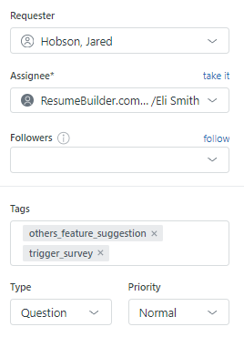

#### 4 & BELOW-RATE; WITH/WITHOUT NEGATIVE FEEDBACK

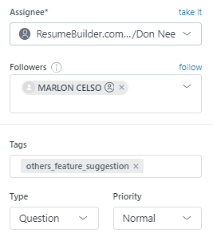

# horizontal lineTRACKER

#### 

#### CUSTOMER SERVICE TRACKER

##### 5-RATE / NO COMPLAINTS

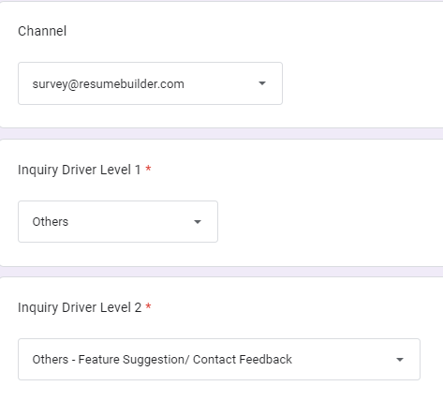

##### 4 & BELOW-RATE / WITH COMPLAINTS

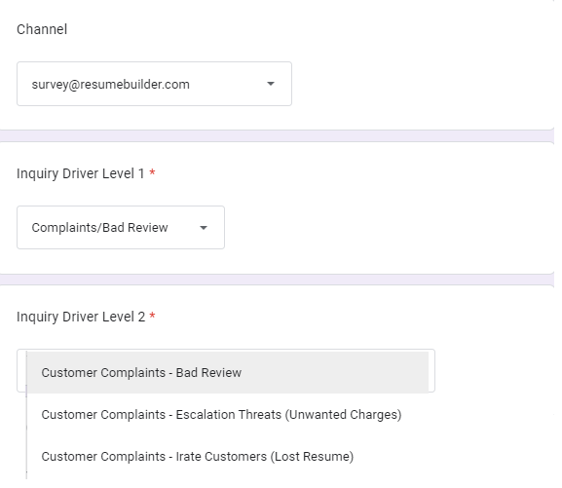

# horizontal lineGMAIL LABELS



